|  |  |  |  |
| --- | --- | --- | --- |
| **Class: FYMCA Div: A**  **Semester: II** | **Course Code:**  MCA01554  **Course Name: Java Programming Laboratory** | | **Batch:**  **F1** |
| **Name: Anurag Dalal** | | **Roll No: 51009** | |
| **CO No: CO515.4** | | **Assignment No: 10** | |

**PRACTICAL SUBMISSION RECORD- A.Y. 2024-25**

Title:

Write JDBC backend class, which establishes a connection with the database having a table “STUDENT” with structure – roll no, name, class, DOB. Using the above backend class WAP to accept roll_no from command line and display the details with proper error messages. Display all the records from table with proper formatting.

Code:

SQL:

Create Database student

CREATE TABLE IF NOT EXISTS students (

id INT AUTO_INCREMENT PRIMARY KEY,

name VARCHAR(100),

age INT,

major VARCHAR(100)

);

Sample Records:

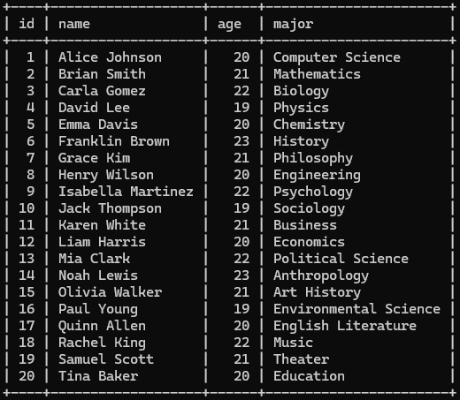

Java:

package practice_java;

import javax.swing.*;

import java.awt.*;

import java.awt.event.*;

import java.sql.*;

public class Assignment_No_10 extends JFrame {

JTextField idField, nameField, ageField, majorField;

JButton firstBtn, nextBtn, prevBtn, lastBtn;

Connection conn;

Statement stmt;

ResultSet rs;

public Assignment_No_10() {

super("Student Record Navigator");

setLayout(new GridLayout(6, 2));

add(new JLabel("ID:"));

idField = new JTextField(20);

idField.setEditable(false);

add(idField);

add(new JLabel("Name:"));

nameField = new JTextField(20);

nameField.setEditable(false);

add(nameField);

add(new JLabel("Age:"));

ageField = new JTextField(20);

ageField.setEditable(false);

add(ageField);

add(new JLabel("Major:"));

majorField = new JTextField(20);

majorField.setEditable(false);

add(majorField);

firstBtn = new JButton("First");

nextBtn = new JButton("Next");

prevBtn = new JButton("Previous");

lastBtn = new JButton("Last");

add(firstBtn);

add(nextBtn);

add(prevBtn);

add(lastBtn);

connectDatabase();

firstBtn.addActionListener(e -> navigate("FIRST"));

nextBtn.addActionListener(e -> navigate("NEXT"));

prevBtn.addActionListener(e -> navigate("PREVIOUS"));

lastBtn.addActionListener(e -> navigate("LAST"));

navigate("FIRST");

setSize(400, 250);

setDefaultCloseOperation(JFrame.***EXIT_ON_CLOSE***);

setVisible(true);

}

void connectDatabase() {

try {

Class.*forName*("com.mysql.cj.jdbc.Driver");

conn = DriverManager.*getConnection*("jdbc:mysql://localhost:3308/student", "root", "tiger");

stmt = conn.createStatement(ResultSet.***TYPE_SCROLL_INSENSITIVE***, ResultSet.***CONCUR_READ_ONLY***);

createTableIfNotExists();

rs = stmt.executeQuery("SELECT * FROM students");

} catch (Exception e) {

JOptionPane.*showMessageDialog*(this, "Database Connection Failed: " + e);

}

}

void createTableIfNotExists() {

try {

String sql = """

CREATE TABLE IF NOT EXISTS students (

id INT AUTO_INCREMENT PRIMARY KEY,

name VARCHAR(100),

age INT,

major VARCHAR(100)

);

""";

stmt.executeUpdate(sql);

} catch (SQLException e) {

JOptionPane.*showMessageDialog*(this, "Table Creation Failed: " + e);

}

}

void navigate(String direction) {

try {

switch (direction) {

case "FIRST":

rs.first();

break;

case "NEXT":

if (!rs.isLast()) rs.next();

break;

case "PREVIOUS":

if (!rs.isFirst()) rs.previous();

break;

case "LAST":

rs.last();

break;

}

displayRecord();

} catch (SQLException e) {

JOptionPane.*showMessageDialog*(this, "Navigation Error: " + e);

}

}

void displayRecord() {

try {

idField.setText(String.*valueOf*(rs.getInt("id")));

nameField.setText(rs.getString("name"));

ageField.setText(String.*valueOf*(rs.getInt("age")));

majorField.setText(rs.getString("major"));

} catch (SQLException e) {

JOptionPane.*showMessageDialog*(this, "Error Displaying Record: " + e);

}

}

public static void main(String[] args) {

new Assignment_No_10();

}

}

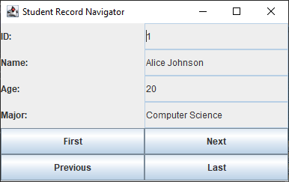Output: